Register (Normal)
- Used for Registering user to app
- API - http://limonchilli.com/app/api/index.php/12345/register

INPUT:

POST following data to above url .
Case 1: With Registration from form
Required : fname ,lname , email , password , cpassword
Not Required: phone , dob

Case 2: With Registration from facebook (only for first time)
Required : fname ,lname , email , unique_id, login_with {facebook}
Not Required: phone , dob

Case 3: With Registration from google (only for first time)
Required : fname ,lname , email, login_with {google }
Not Required: unique_id , phone , dob

Case 4: With Registration from twitter (only for first time)
Required : fname ,lname , email, unique_id, login_with {twitter}
Not Required:,phone , dob

OUTPUT (JSON Data):

- {“status” : “true”,”message”:”email_exist”}
=> Email already registered

- {“status” : “true”,”message”:”phone_exist”}
- Phone no already registered

Case 1: If registration from Form
3. {“status” : “true”,”message”:” otp_sent”,”data”:{USERDATA}}
=> Registered successfully , OTP sent , returned user data
4. {“status” : “true”,”message”:” otp_not_sent”,”data”:{USERDATA}}
=> Registered successfully , OTP not sent , returned user data

Case 2: If registration from Social Platforms
5. {“status” : “true”,”message”:” success”,”data”:{USERDATA}}
=> Registered successfully , returned user data

6 . {“status” : “false”,”message”:” Please provide all required paramaters.”}
- Any required parameter is missing
USERDATA format: "first_name":"mukesh","last_name":"rai","email":"mukesh.think360@gmail.com","login_with":"form","phone":"123456789","otp":504672,"ID":33

Login (Normal)
- Used for Login user to app
- API - http://limonchilli.com/app/api/index.php/12345/login

INPUT:

POST following data to above url .
Required : email (either email or phone) , password

OUTPUT (JSON Data):

- {“status” : “false”,”message”:”invalid”}
=> incorrect email/phone or password

- {“status” : “true”,”message”:”deactivated”,”data”:{USERDATA}}
=> user have not verified you account , returned user data

3. {“status” : “true”,”message”:” success”,”data”:{USERDATA}}
=> login success , returned user data
4. {“status” : “false”,”message”:” Please provide all required paramaters.”}
- Any required parameter is missing
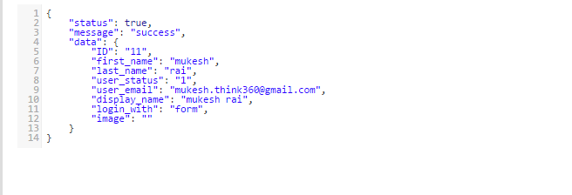

Social Login
- Used for Login user to app using social network API’s
- API - http://limonchilli.com/app/api/index.php/12345/social_login

INPUT:
POST following data to above url .

Case 1: With Login from facebook (only for first time)
Required : unique_id, login_with {facebook}

Case 2: With Login from google (only for first time)
Required : email, login_with {google }

Case 3: With Login from twitter (only for first time)
Required : unique_id, login_with {twitter}

OUTPUT (JSON Data):

- {“status” : “true”,”message”:”new_user”}
=> New User , first time login from Social Platforms

- {“status” : “true”,”message”:”success”,”data”:{USERDATA}}
- Login success , returned user data
3. {“status” : “false”,”message”:” Please provide all required paramaters.”}
- Any required parameter is missing

Account Verification (Using OTP sent on email)
- Used for verifying user account
- API - http://limonchilli.com/app/api/index.php/12345/activate

INPUT:

POST following data to above url .
Required : userid, otp

OUTPUT (JSON Data):

- {“status” : “true”,”message”:”invalid”}
=> incorrect OTP
- {“status” : “true”,”message”:”success”}
=> OTP successfully verified
3. {“status” : “false”,”message”:” Please provide all required paramaters.”}
- Any required parameter is missing

Resend account verification OTP
- Used for resending OTP for account verification on user email
- API - http://limonchilli.com/app/api/index.php/12345/resend_otp

INPUT:

POST following data to above url.
Required : userid

OUTPUT (JSON Data):

- {“status” : “true”,”message”:”success”}
=> OTP sent successfully

Forgot Password
- Used for reset user password
- API - http://limonchilli.com/app/api/index.php/12345/forgot_password

INPUT:

POST following data to above url .
Required : email

OUTPUT (JSON Data):
- {“status” : “false”,”message”:”deactivated”}
=> user have not verified you account , returned user data

- {“status” : “false”,”message”:”invalid”}
=> email does not exist

- {“status” : “true”,”message”:” registered_with_social_network”}
=> This email is registered with social network login. So login with social network

- {“status” : “true”,”message”:”success”}
=> New Password has been sent successfully on user email

Categories
- Used for finding categories
- API - http://limonchilli.com/app/api/index.php/12345/categories

INPUT:
Use request type GET

OUTPUT (JSON Data):

- {“status” : “true”,”message”:”success”,data:{CATEGORYDATA}}

CATEGORYDATA format: 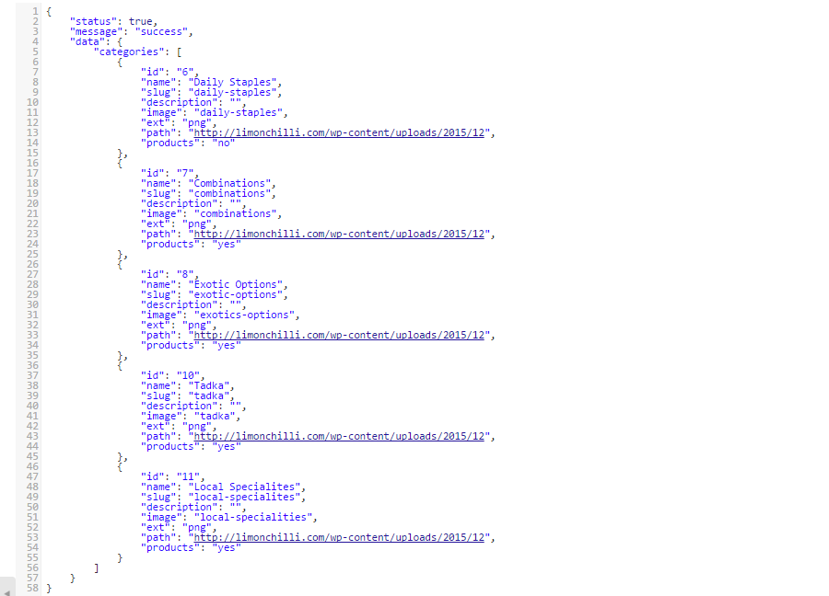

Sub categories
- Used for finding sub categories inside the categories..
- API - http://limonchilli.com/app/api/index.php/12345/categories?category=6&page=2
- http://limonchilli.com/app/api/index.php/12345/categories?category=daily-staples&page=3

INPUT:
Use request type GET

OUTPUT (JSON Data):

- {“status” : “true”,”message”:”success”,data:{CATEGORYDATA}}

CATEGORYDATA format:
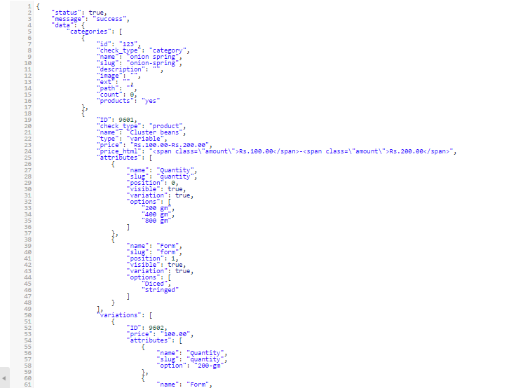

Products
- Used for finding products inside the categories….
- API - http://limonchilli.com/app/api/index.php/12345/products?category=7&page=2
- http://limonchilli.com/app/api/index.php/12345/products?category=potato&page=4

INPUT:
Use request type GET

OUTPUT (JSON Data):

- {“status” : “true”,”message”:”success”,data:{ProductDATA}}

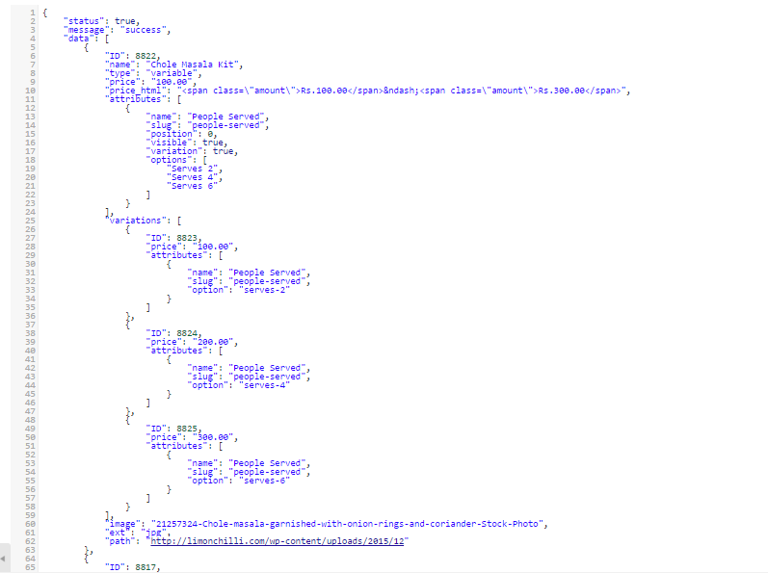

Single Product
- Used for finding products inside the categories….
- API - http://limonchilli.com/app/api/index.php/12345/product?product_id=7&user_id=12

INPUT:
Use request type GET

OUTPUT (JSON Data):

- {“status” : “true”,”message”:”success”,data:{ProductDATA}}
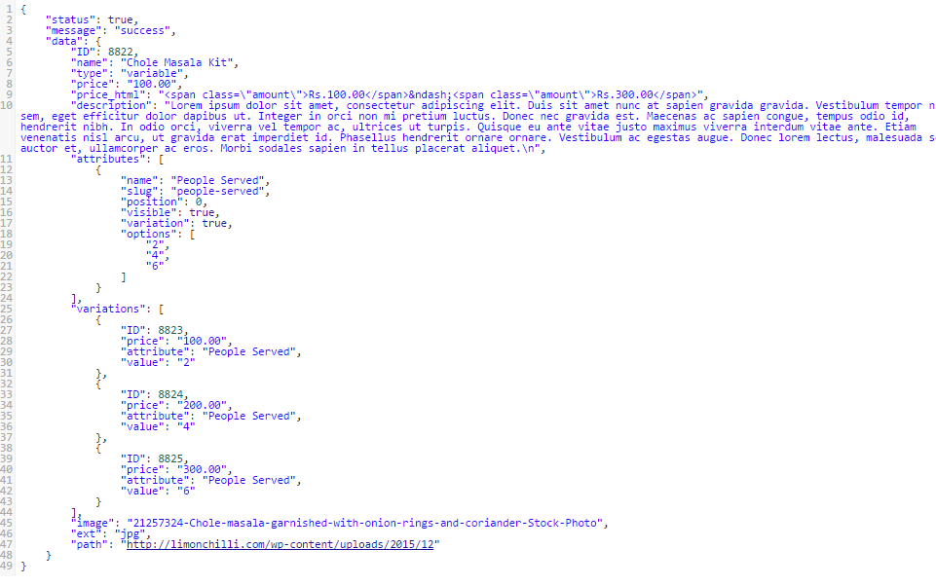

Get Product Variations
- Used for finding products inside the categories….
- API - http://limonchilli.com/app/api/index.php/12345/product_details

INPUT:
Post following data to above url:
Required: product_id
attributes: diced*200gm or diced

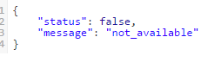
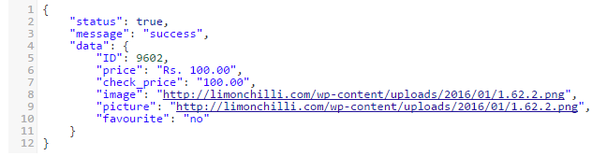

Create Order
- Used for create a new order
- API - http://limonchilli.com/app/api/index.php/12345/create_new_order

INPUT:

Post following data in same format to above url..
Required: user_id , payment_method(cod/paytm),paid(true/false), products ({product_id:2,quantity:2},{product_id:5,quantity:3},….) , delivery_date , delivery_time

Optional: billing_address{first_name,last_name,address_1,address_2,city,state,postcode,country,phone},

shipping_address{first_name,last_name,address_1,address_2,city,state,postcode,country }

OUTPUT (JSON Data):

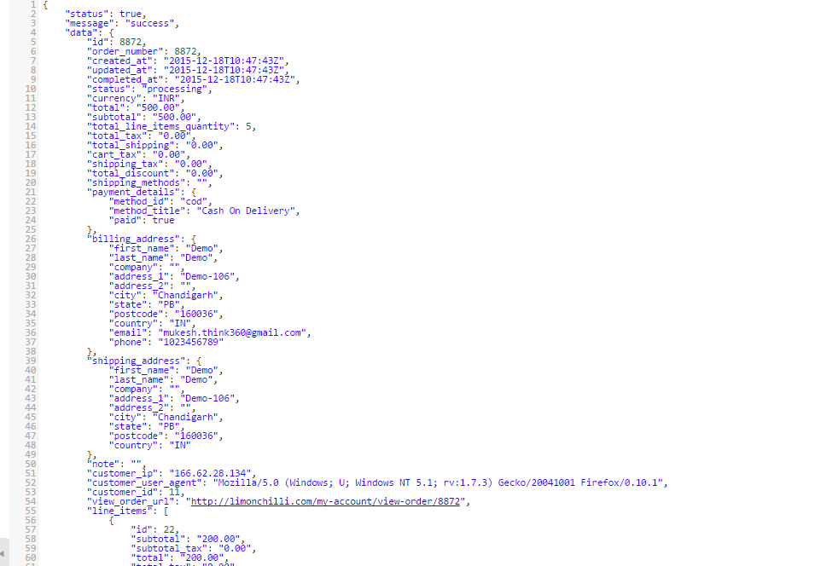

Update Order Payment Status
- Used for create a new order
- API - http://limonchilli.com/app/api/index.php/12345/update_order

INPUT:

Post following data in same format to above url..
Required: order_id , payment_method(cod/paytm),paid(true/false)
OUTPUT (JSON Data):
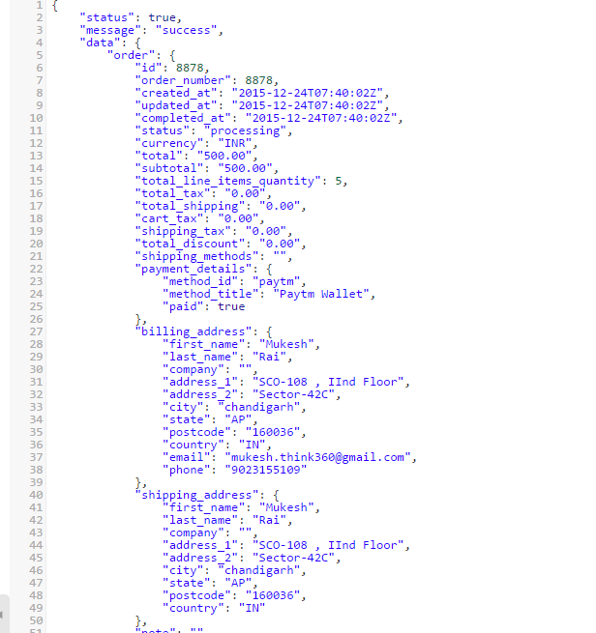

Get Available time Slots on a date

- API - http://limonchilli.com/app/api/index.php/12345/get_available_time_slots

INPUT:
Post following data in same format to above url..
Required: date ( in d-m-Y format, like 15-02-2016)

Get User Details
- Used for finding user details
- API - http://limonchilli.com/app/api/index.php/12345/get_user?user_id=20

INPUT:

Use Request Type GET

OUTPUT (JSON Data):
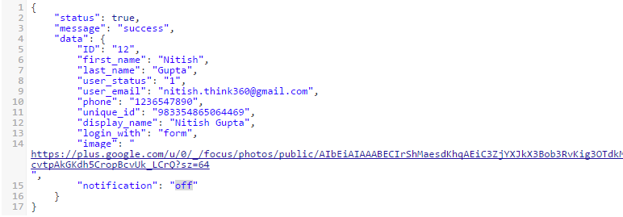

Get User Orders
- Used for finding user details
- API - http://limonchilli.com/app/api/index.php/12345/get_user_orders?user_id=20

INPUT:

Use Request Type GET

OUTPUT (JSON Data):

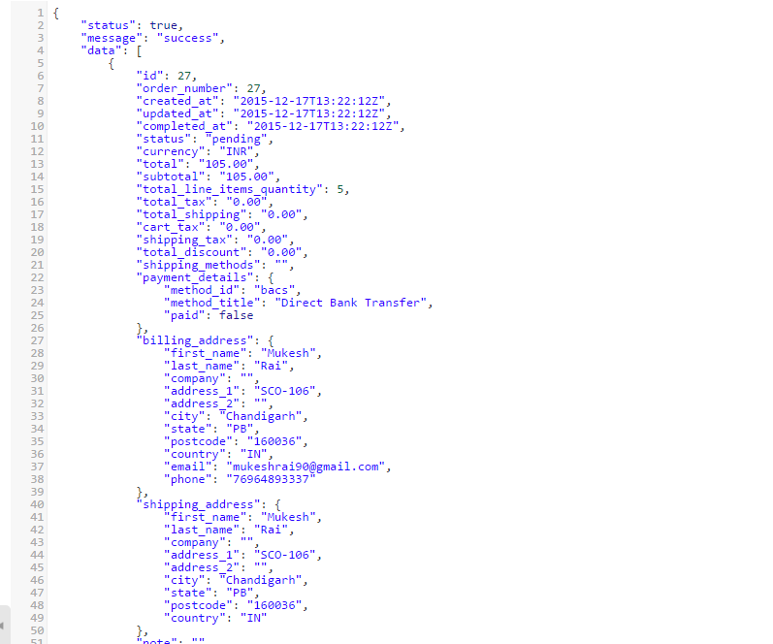

Get Order
- Used for finding user details
- API - http://limonchilli.com/app/api/index.php/12345/get_order?order_id=20

INPUT:

Use Request Type GET

OUTPUT (JSON Data):
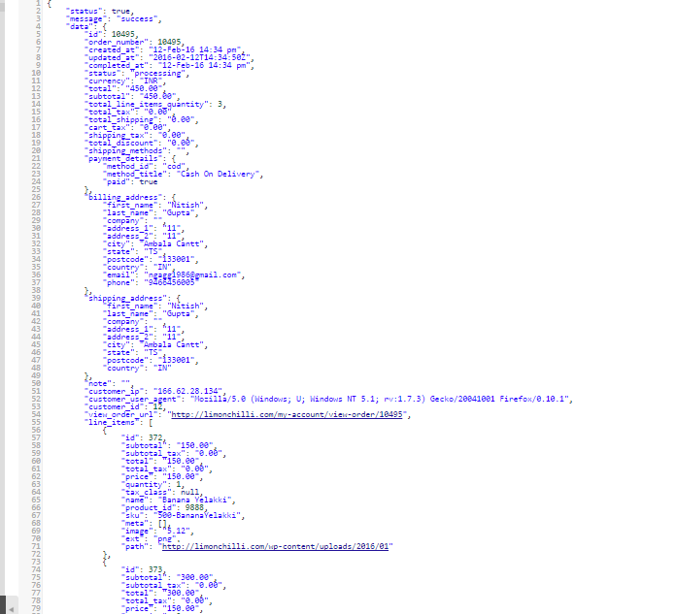

Update Profile
- Used for updating user’s profile
- API - http://limonchilli.com/app/api/index.php/12345/update_user

INPUT:

POST following data to above url .
Required : user_id , fname ,lname , email
Not Required: dob , password , cpassword , old_password

OUTPUT (JSON Data):

- {“status” : “true”,”message”:”email_exist”}
=> Email already registered

- {“status” : “true”,”message”:”phone_exist”}
- Phone no already registered
3 . {“status” : “false”,”message”:” Please provide all required paramaters.”}
- Any required parameter is missing

User Saved Address
- Used for getting user’s addresse
- API - http://limonchilli.com/app/api/index.php/12345/get_user_address?user_id=20

INPUT:

Use Request Type GET

OUTPUT (JSON Data):

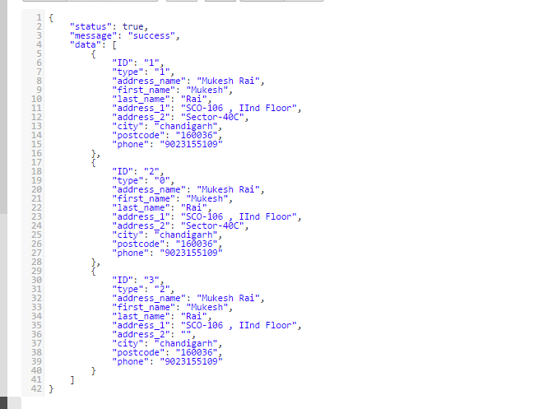

Get a Address
- Used for getting user’s address details
- API - http://limonchilli.com/app/api/index.php/12345/get_address?address_id=2

INPUT:

Please use request type GET

OUTPUT (JSON Data):

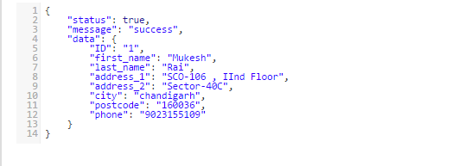

Delete a Address
- Used for deleting user’s addressess
- API - http://limonchilli.com/app/api/index.php/12345/delete_address?address_id=2

INPUT:

Please use request type GET

OUTPUT (JSON Data):

- {“status” : “true”,”message”:”success”}
=> Deleted successfully

Add Address
- Used for adding new user’s addressess
- API - http://limonchilli.com/app/api/index.php/12345/user_address

INPUT:

Post following data in same format to above url..
Required: user_id , type(0=>Home,1=>Office,2=>Other),first_name,last_name,address_1, address_2,city,postcode,phone

OUTPUT (JSON Data):

- {“status” : “true”,”message”:” add_success”}
=> Added Successfully

Update Address
- Used for updating user’s addressess
- API - http://limonchilli.com/app/api/index.php/12345/user_address

INPUT:

Post following data in same format to above url..
Required: address_id,user_id , type(0=>Home,1=>Office,2=>Other),first_name,last_name,address_1, address_2,city,postcode,phone

OUTPUT (JSON Data):

- {“status” : “true”,”message”:” update_success”}
=> Updated Successfully

Getting Details of Products in cart
- Used for getting products details that are in cart
- API - http://limonchilli.com/app/api/index.php/12345/get_cart_products

INPUT:
Post following data to above url:
products: {"2":"8812_1","1":"8817_2","0":"8823_3"} (in JSON format)

OUTPUT (JSON Data):

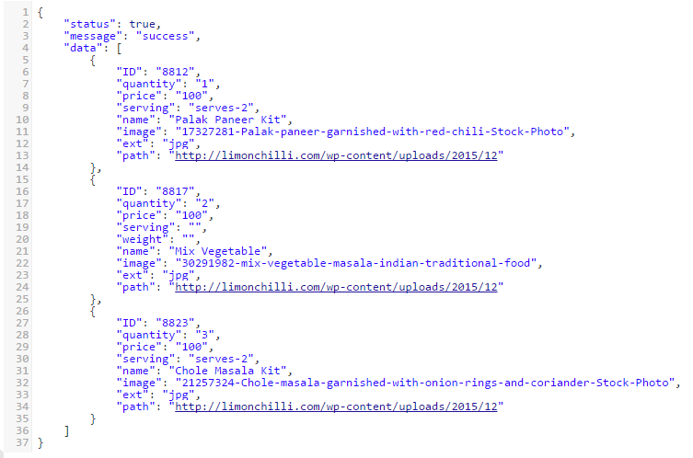

Set an address as default
- Used for setting an address as default address
- API - http://limonchilli.com/app/api/index.php/12345/set_default_address?address_id=2

INPUT:
Use REQUEST type GET

OUTPUT (JSON Data):
1. {“status” : “true”,”message”:” success”}

Get user's default address
- Used for getting a user's default address
- API - http://limonchilli.com/app/api/index.php/12345/get_default_address?user_id=20

INPUT:
Use REQUEST type GET

OUTPUT (JSON Data):
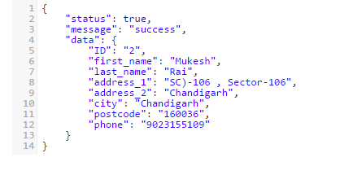

Get user's favourite
- Used for getting favourite products
- API - http://limonchilli.com/app/api/index.php/12345/get_favourites?user_id=12

INPUT:
Use REQUEST type GET

OUTPUT (JSON Data):
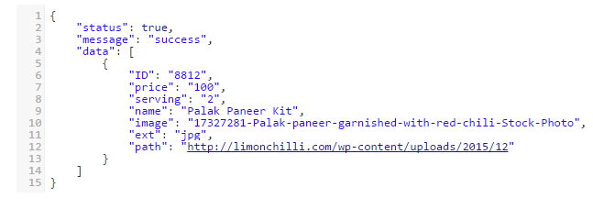

Remove a product from user's favourite
- Used for remove a product from user favourite
- API - http://limonchilli.com/app/api/index.php/12345/remove_favourites?favourite_id=12

INPUT:
Please use request type GET

OUTPUT (JSON Data):
      - {“status” : “true”,”message”:” success”}

Set a product as favourite
- Used for setting a product in user favourite
- API - http://limonchilli.com/app/api/index.php/12345/set_favourite

INPUT:
Post following data to above url:
required: user_id , product_id

OUTPUT (JSON Data):
1. {“status” : “true”,”message”:” success”}

Get different counts of user
- Used for setting a product in user favourite
- API - http://limonchilli.com/app/api/index.php/12345/get_counts?user_id=12

INPUT:
Use REQUEST type GET

OUTPUT (JSON Data):
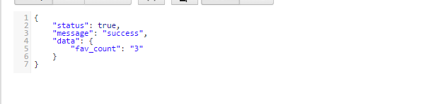

Adding products to cart
- Used for adding/updating a product in user cart
- API - http://limonchilli.com/app/api/index.php/12345/user_cart

INPUT:
POST following data to above url
Required: user_id , product_id , quantity

OUTPUT (JSON Data):
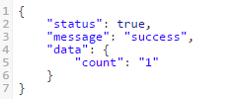

Getting users cart product
- Used for getting all products in user cart
- API - http://limonchilli.com/app/api/index.php/12345/get_user_cart

INPUT:
POST following data to above url
Required: user_id

OUTPUT (JSON Data):
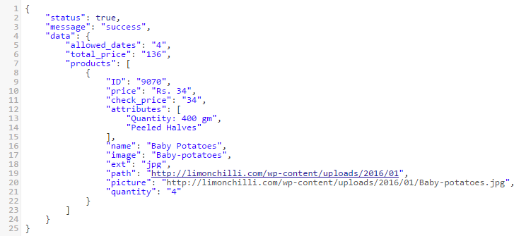

Deleting a product from user cart
- Used for deleting a product from user cart
- API - http://limonchilli.com/app/api/index.php/12345/delete_cart

INPUT:
POST following data to above url
Required: user_id , product_id

OUTPUT (JSON Data):
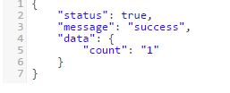

Search Products
- Used for searching products by keyword
- API - http://limonchilli.com/app/api/index.php/12345/search_products

INPUT:

POST following data to above url .
Required : keyword

OUTPUT (JSON Data):
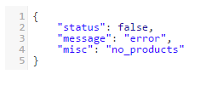
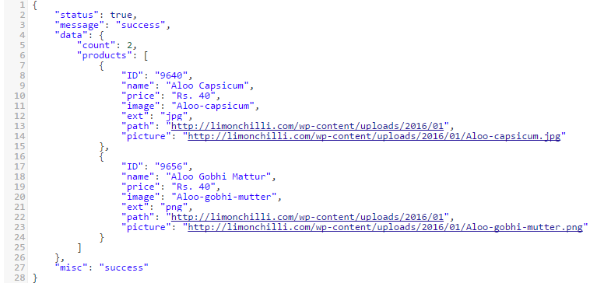

Cancel Order Request
- Used place a cancel order request
- API - http://limonchilli.com/app/api/index.php/12345/cancel_oreder

INPUT:

POST following data to above url .
Required : order_id

OUTPUT (JSON Data):

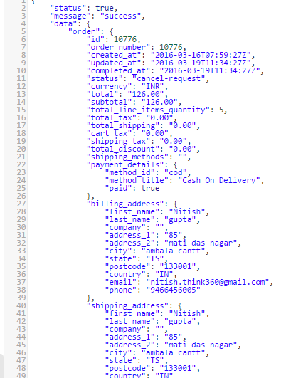
User settings
- User for make user notifications on/off
- API - http://limonchilli.com/app/api/index.php/12345/user_settings

INPUT:

POST following data to above url .
Required : user_id , notification(on/off)
OUTPUT (JSON Data):
