**What is Project Studio?**

Project Studio is an exclusive virtual workspace for each project team to collaborate and manage their project. The space is accessible to the client, mentor and students working on the specific project.

**Why should I use Project Studio?**

Project Studio primarily helps a project team to collaborate virtually and:

* **Define key tasks** that – when completed – will collectively deliver the required outputs and move the project to a successful conclusion;
* **Assign team members** to each task to ensure a clear and shared responsibility for successful execution of the project. The task owner primarily coordinates relevant activities and may involve other team members in the execution;
* **Set out timelines** for each task to help track and manage progress. This is particularly critical for managing “dependencies” (*where a task is contingent on the successful completion of another*) and scheduling client review sessions;
* **Synthesise content** by sharing and integrating content (files) from individual team members into an integrated and consistent output. Project Studio makes it easy for team members to review and comment on the content in a transparent process that ensures buy-in from all team members;
* **Seek and incorporate client and mentor feedback** at regular intervals. Project Studio allows the team to upload interim outputs for the client or mentor to review and comment on, in a virtual and time-efficient process.

**Can the project team communicate or collaborate outside Project Studio?**

A project team is free to communicate and collaborate in any way it chooses. We offer Project Studio as a ***free optional*** feature that the project team can use either exclusively or in addition to other tools.

Project Studio is a bespoke tool developed specifically to support virtual project teams to manage work-plans, co-create outputs and interact with clients and mentors. We will continue to refine and update Project Studio to better service the needs and preferences of our community members.

**When is the Project Studio accessible to the project team?**

A project team can access its Project Studio when the project goes live. The Project Studio remains open to the client, mentor and students in the team for the duration of the project and an additional 30 days after its completion. Thereafter the team can access copies of the final deliverables in the Completed Projects tab of their respective dashboard.

**What are the different sections of the Project Studio?**

Project Studio has the following 8 sections:

1. **Portfolio** is a summary view of the outstanding tasks, upcoming events, task completion status and activity timeline across *all* Live projects that you are involved in. The section also includes **sticky notes** to record key points and a **chat box** to communicate with team members.
2. **Projects** is a list of all Live projects that you are currently involved in. You can click on a project title to start collaborating with the project team (*refer to the next FAQ for more details*).
3. **Tasks** highlights all outstanding tasks and timelines across all Live projects that you are involved in. You can click on a task to view relevant details. The tasks can be viewed by all team members as a list or as a kanban.
4. **Calendar** gives a view of key meetings and events (including team meetings) for all Live projects that you are involved in.
5. **Messages** allows you to chat with or send messages to other team members. You can also attach files to the message.
6. **Notes** allows you to record your thoughts and comments for your personal reference. The content of this section *cannot* be viewed by anyone else.
7. **To Do List** is a personal log of additional tasks or activities that you wish to maintain. The content of this section *cannot* be viewed by anyone else.
8. **Support** includes an expanding list of content to help users familiarise themselves with Project Studio and enjoy its many different tools and features.

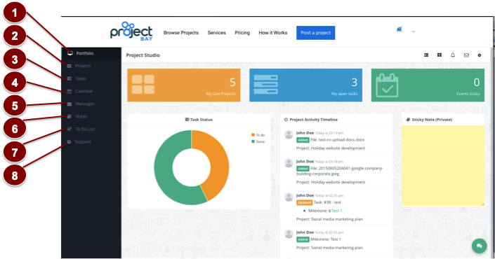

**Where and how does a project team collaborate in Project Studio?**

You can collaborate with your project team in an exclusive virtual workspace in Project Studio. You can access the space either by clicking on the “Project Studio” button in the Live Project tab of your dashboard or by clicking on the Project Title within the “Projects” tab of Project Studio.

Here, you can collaborate with your team through 7 sections:

1. The **Overview** section summarises project objectives, team members, task completion rate and activity summary.
2. The **Tasks List** outlines key tasks, timelines and ownership. Clients or mentors can click on the *Add Task* button to define tasks or click on the task name to modify task details.
3. **Tasks Kanban** offers a visual representation of task status – *To Do*, *In Progress* or *Completed*. Team members can drag tasks from their default *To Do* position to update their status. The tasks can be filtered by timeline or ownership.
4. **Milestones** records key events or meetings related to the project. Team members can click on the *Add Milestone* button to define a milestone or on the milestone to update details.
5. **Gantt** offers a timeline view of all tasks and milestones for the project based on the content in Task List and Milestone sections.
6. The **Files** section allows team members to share, review and comment on files.
7. The **Comments** section allows team members to share their comments on specific tasks, milestones or files as well as respond to others’ comments.

In addition, each team member can use the **Notes** section to record personal thoughts on the project. The content of this section cannot be seen by other members of the team.

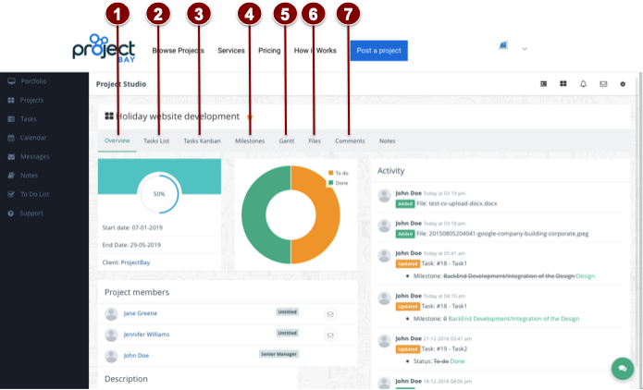

**Where can I find a tutorial on Project Studio?**

You can watch the tutorial video on Project Studio here.