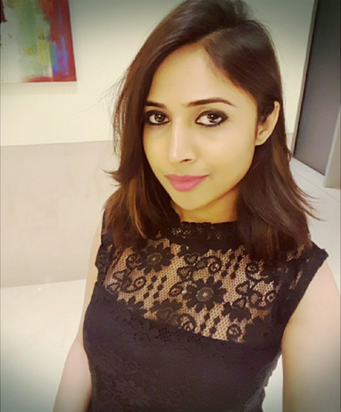

**MANJURANI NAGSHETTY**

e-mail: [manjunagshette@gmail.com](mailto:manjunagshette@gmail.com) ,

Phone number: 07510889021,

LinkedIn: <https://www.linkedin.com/in/manjurani-nagshetty-a69454106/>

|  |  |
| --- | --- |
| **SUMMARY** |  |

* Creative and dedicated professional with more than seven years’ experience in all aspects of business: management, events marketing, budget control and inventory.
* Proven work ethic, communication and organizational skills, with a passion for sustainable business development.

|  |  |
| --- | --- |
| **AWARDS – Rising Star Award (2018)** |  |

* Awarded with a RISING STAR AWARD from Telangana Artists Association Virtuoso Awards 2018.

|  |  |
| --- | --- |
| **BUSINESS EXPERTISE** |  |

|  |  |
| --- | --- |
| * Strategic Planning * Operations Management * Artist Management * Staff Training & Development | * Contract Negotiations * Budget management * Trend Analysis * Digital Marketing |

|  |  |
| --- | --- |
| **PROFESSIONAL EXPERIENCE** |  |

**DAIKI ENTERTAINMENT- 2017 - Present**

(Co- Founder, Artist and Celebrity Manager)

* Managed top Bollywood and Tollywood artists to all kinds of events like weddings, college festivals, concerts and corporate events.
* Always aim to stand out in managing and sourcing best artists that provide highest value for money to the client.
* Meeting the client requirement and expectations is very important for a business to be successful. As a co-founder of the company, always work towards achieving these goals .
* Effectively use social media to build relationship with client, market the business, and keep up with industry trends.

**TRADITIONS EVENT MANAGEMENT AND MARKETING - 2014 - 2017**

(Event Manager 2014 to 2015 and Senior event manager 2015 to 2017)

* Assisted in executing internal and external events, including trade shows, conferences, and parties.
* Established and built successful partnerships with vendors, hotels, event management companies, and production services companies.
* Facilitated effortless planning process for hosts.
* Developed event décor and ambiance based on client vision and budget.
* Utilized financial strategy and negotiations to maximize parameters of an event within a client’s budget.
* Attracted new clients and maintained pre-existing clients through excellent word of mouth advertising and feedback.

**R K INTERIORS - 2012 - 2014**

(Marketing Manager)

* Created professional presentations to creatively communicate design intent and directions.
* Successfully assisted clients in choosing furnishings with their preferences and budget.
* Order and supervise delivery of material.
* Contributed in marketing and business strategies and ideas to the company.
* Facilitate project meetings with clients and constructions and installation professionals.

|  |  |
| --- | --- |
| **EDUCATION** |  |

* Pursuing MBA from Brunel University London 2019-20.
* Bachelor’s of Engineering from Visvesvaraya Technological University, India.